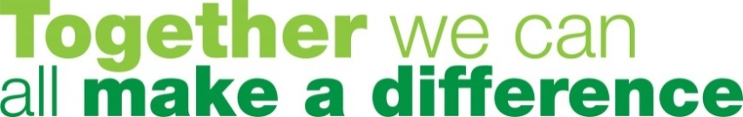
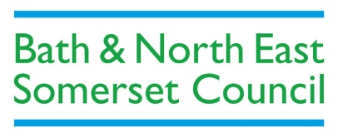
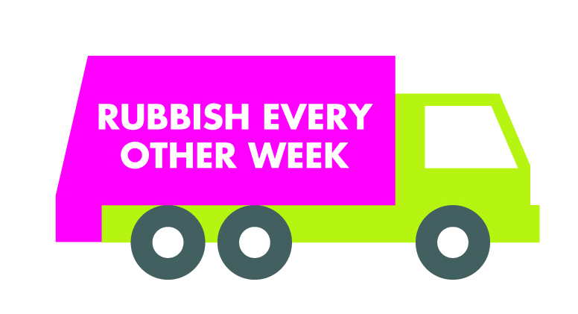

Rubbish every other week container allocation reminder – 5 May deadline for queries
Just to remind all residents that you have until 5 May 2017 to contact us if you have any queries with the container allocated to you in the letter we sent to you in March.
Check your new bin allocation by entering your address at www.bathnes.gov.uk/recycle
If despite recycling all you can, you feel that your household will not manage with your allocated container, please complete the online form at www.bathnes.gov.uk/bin by 5 May. We will investigate to see if your circumstances are appropriate for an alternative. We may visit you and help you make the best use of your recycling collection.
Register your interest now for free text collection reminders when the new service starts - text your postcode to 07520631700
View our frequently asked questions about the changes at www.bathnes.gov.uk/recycle
View the new rubbish containers at our roadshows, at Council One Stop Shops and community venues www.bathnes.gov.uk/roadshows
Like us on Facebook www.facebook.com/recycleforbathnes for tips to help you recycle more!

