B&NES Request Proforma
This proforma is to be used to request the consideration of your community area for a low traffic neighbourhood and/or residents’ parking zone. It also provides the opportunity for communities, as part of this request, to put forward ideas for the reimagination of road-space and identify potential locations for public realm improvements (i.e. parklets, public art, planters etc.), or infrastructure (i.e. footway widening, cycle lanes, cycle parking, on-street electric vehicle charging points etc.).
The Climate Emergency and Covid-19 pandemic are changing the way people think about their local neighbourhoods and how they travel. For many, these fundamental changes have reminded us what our streets and public spaces could be like, the benefits of walking and cycling particularly for local trips, and the need for social distancing highlighting that pavements in many areas are too narrow, with road space disproportionately allocated in favour of motor vehicles.
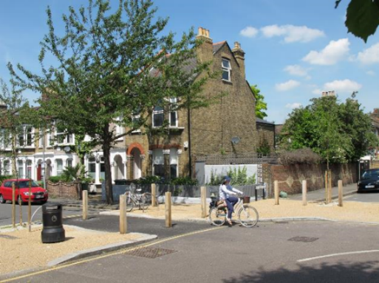
Low traffic neighbourhoods provide a valuable tool to reconsider how streets are managed to enable inclusive and safer environments, to promote active travel and encourage mode shift away from private cars. Principles of a low traffic neighbourhood focus on reducing the dominance of “rat-running” traffic to deliver attractive, healthy, accessible and safe neighbourhoods for people. This generates opportunities in residential areas to improve conditions for walking and cycling, as well as access to public transport and community spaces. Importantly residents remain able to drive on their streets, park on their streets and receive deliveries.
Residents’ parking schemes not only help control non-residential parking within an area, the can also help rationalise space within a community and help to reduce car ownership and usage by residents. Residents’ parking zones can be requested separately or in conjunction with a low traffic neighbourhood.
Please note, the implementation of a low traffic neighbourhood, residents’ parking zone or any the proposed solutions are not guaranteed through the completion of this form.

Name of Councillor and ward | Sarah Warren & Kevin Guy Bathavon North
Has the Ward submitted any other low traffic neighbourhood/RPZ/ EV charging applications? | Yes
Signature of Ward Councillor | Sarah Warren

Problem(s) experienced prompting the request | Bathampton is the rat run for the East of Bath for vehicles that want to avoid the city centre and traffic on Cleveland Bridge. It is also now the rat run for non-compliant LGVs and Taxis to avoid the Clean Air Zone. With Cleveland Bridge shut, issues were compounded for the duration and mitigation crossings had to be put in place. Problems experienced generally in the village are a far higher volume of traffic than a narrow-street village should have through it, with volumes forecast by B&NES to increase significantly due in part to the enterprise zone. On top of this, there are individual pinch point spots where crossing is highly dangerous.  There is a particular focus in this LNS request on the area on the rat run described above from the Canal Bridge, along the High Street and left up Down Lane. Separately, speeding occurs on Bathampton Lane where occasional speed humps are ineffective and on the A36 there are excessive speeds and severance crossing issues.  Within this context, Bathampton Primary School and the Parish Council have been travel planning since 2016 and the school has its Travel Plan safety issues published on the school website. These were informed by a detailed parent survey that highlighted that crossings were the primary concern (the canal bridge, to the George Pub where parents park for school, the middle of Down Lane between Holcombe Lane/Devonshire Road and the A36). The second concern was fast roads – Mill Lane (where investment was granted in 2018 to lower the speed limit and make the pavements consistent) and the A36 Warminster Road. More recently, there has been work with the Parish Council and High Street recently to tease out how best to support this stretch of the village and complement work done on the canal bridge to resolve serious safety issues.  https://www.bathamptonprimary.org/cms/wp-content/uploads/BPS-Travel-Plan-safety-improvement-on-a-page.pdf  To tackle the issue of safety on the A36 Warminster Road, this road is owned by Highways England and the Parish Council has consulted on a scheme to deliver far safer crossing North to South, which would be in conjunction with HE. https://bathamptonparishcouncil.org.uk/highways-canal/highways-consultation  This work with Highways England does not tackle the topics in the LNS:  - Down Lane:  - The severance issue of crossing in the middle of Down Lane West to East though as this is B&NES Highways and this Liveable Neighbourhoods application seeks to resolve this issue.  - It shows that there needs to be an overall plan through the length of Down Lane even if different parties own different sections of road.  - Another known and critical pinch point safety issue is that of the canal bridge where the community invested time and money, with B&NES Highways support throughout, to bring forward a new foot and cycle bridge in 2018, the Conker Crossing project. The manned set of lights during Cleveland bridge works has now been replaced by a crossing patrol that has taken crossing patrol resource away from the school car park crossing at the George. This area is the focus of Summer 2022 assessment by AECOM on BANES’ behalf to find a solution on the and around the canal bridge itself, subject of consultation by the parish Council in November 2022.  - Connecting Down Lane to the canal bridge is the High Street. This narrow road is a very challenging environment for drivers, residents and pedestrians. Much work has been done with the High St residents to bring together ideas that will create a much more liveable neighbourhood. This is critical to set alongside the Canal Bridge work to alleviate any impact of this solution  Issues as numbered in this document.  - Down Lane. There are a number of high-risk hazards along Down Lane, which is the central North/South road that runs through Bathampton. Crossing the road at the end of Devonshire road is dangerous due to poor visibility and lack of pavement infrastructure. Combined with cars parked at the top of Down Lane, effectively tuning it into a single-track road, with car speed up and down the road to get through/pull in. Cars frequently exceed the 20mph limit by a significant margin, and safety is impacted all the way down to the junction with Holcombe Lane where visibility is poor and pavements lacking. This is a core location in the centre of the village and the staggered junction in between Devonshire Road, Down Lane and Holcombe Lane with the hazards described above means there is no safe crossing spot to get from the East of the village to the West. To the East are the amenities – shops, swings & park, village hall, school and church. To the West are houses and access to Bath.  - The canal bridge in Bathampton is a known, significant longstanding hazard to pedestrians and cyclists. While options for the Conker Crossing bridge are progressed, a Transport solution is requested to ensure that the current lights in operation due to Cleveland Bridge are not removed without there being an agreed replacement solution so we do not revert back to the dangerous situation in place prior. Issues are worst during the school run but are not limited to this time of day. If the Conker Crossing is not deliverable in the short-term, other alternatives need to be explored – crossing patrol terms & conditions, a transport solution using traffic lights, alternative bridge solution that solves the safety issue, in particular for the school run tidal flow.  - High Street: a narrow street, with parked vehicles on one side and residential properties on the other that open directly onto the carriage way. Traffic speed up to ‘get through’ and mount the pavement when drivers do not pay due care and attention.
Perceived cause of the issue(s) and problem(s) | - Down Lane. Half way along Down Lane, crossing issues are due to poor visibility and lack of pavement infrastructure, alongside fast vehicle movements vs speed limit and excess traffic due to the rat run route. Parked cars exacerbate the issue creating a single lane for vehicles to use as vehicles overtake then pull in – in the gaps.  - The canal bridge issues are due to vehicle volumes crossing over each other on bridge that doesn’t have visibility nor enough space to pass two cars plus pedestrians that have to share the space  - The cause of the issues is a narrow stretch of road with far too high a volume of cars trying to pass through it  Please see photos below
Geographical area affected by the issue(s) | - Down Lane  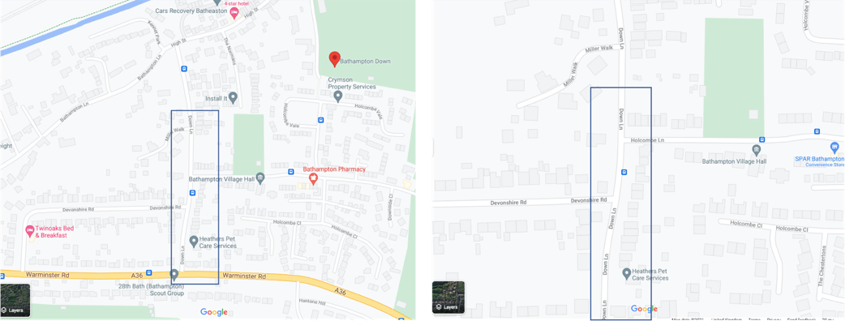  - Canal Bridge  - and High St  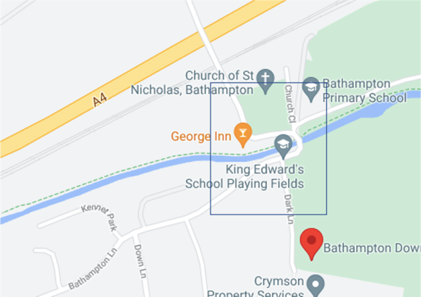  All are in Bathampton Parish Council
Key amenities within the geographical area | Park, shops, village hall, church, school, pub, access to canal
Scale / severity of the problem | - Down Lane. This junction has been the school’s next priority on its Travel Plan after Mill Lane and the Canal bridge since 2016, as determined by detailed consultation with parents as to risks that prevented safe or independent active travel to school. It is a persistent issue – it is the central road in the village and severs East and West.  - Canal Bridge. Severe risk – one resident has broken their neck in the past 18 months and there are daily near misses. The issue is tidal for school although there is a steady flow of other village users throughout the day.  - High Street: a living environment that has significant noise pollution, pollution from idling cars as they wait to pull out to navigate down the High St, as well as the danger of speeding traffic and cars pulling in to avoid each other in informal passing places. In the winter evenings, especially Fridays, cars from the toll bridge can queue up to and along the High St
Types of outcomes/benefits/ opportunities | Safe crossings in both locations that can be navigated by the whole community of any age including children in years 5 & 6 independently coming to school through to elderly residents.  In the High St – a far more pleasant living environment with more orderly flow of traffic

Local level of support this request | - Down Lane.The Parish is currently collecting evidence from local residents to support this application. There is strong support when discussed with residents. This location has been a part of the Bathampton Primary School Travel Plan since 2016 as set out through parent feedback.  https://www.bathamptonprimary.org/cms/wp-content/uploads/BPS-Travel-Plan-safety-improvement-on-a-page.pdf  - Canal Bridge. This issue has significant local support – there is a Parish Council and community-endorsed bridge proposal live as a project with B&NES. See here for our strong public consultation support.  https://bathamptonconkercrossing.com/proposals/  - High Street residents are united in their support for changes to be made. Interested parties have held a number of meetings as a group and have also attended the Parish Council. We also have the following timetable of plans to engage them further:  October/November. Use this draft to match ourselves with best practice elsewhere and/or secure small resource for a mini consultancy from a specialist. Through the Bathampton LNS group  November Bathampton LNS group call a meeting and a small workshop to review this draft of past and new - and develop increasingly tangible ideas/priorities, using whatever help they've been able to garner  15 December PC Receives a proposition from the group. This may still lack specificity of design, but the locations/ visualisation/outcomes would have been prioritised - presumably around calming the High St  Mid-January Half day wider community workshop giving info', taking views  23 Feb PC considers a revised, prioritised proposition for ok - and submission to the B&NES  Bathampton Primary School has worked with the Parish Council and local community since 2016 to understand and respond to the safety concerns raised in order to enable modal shift. The Parish Council always includes an update on this and the school’s progress against its travel plan safety initiatives in its newsletters.  The school’s travel planning is acclaimed – it was the first school in the West of England to achieve Gold Modeshift Stars status in 2019 and in summer 2022 became the first school in the region to achieve a concurrent/double Gold. It has been B&NES Primary School of the Year three times at the Modeshift Stars annual travel awards.  The school community is delivering on its commitment to modal shift – here is the progress since the inception of it using Modeshift Stars. 82% of journeys to school are now active through its work to raise the importance of the issue, despite only 50% of pupils living in Bathampton.  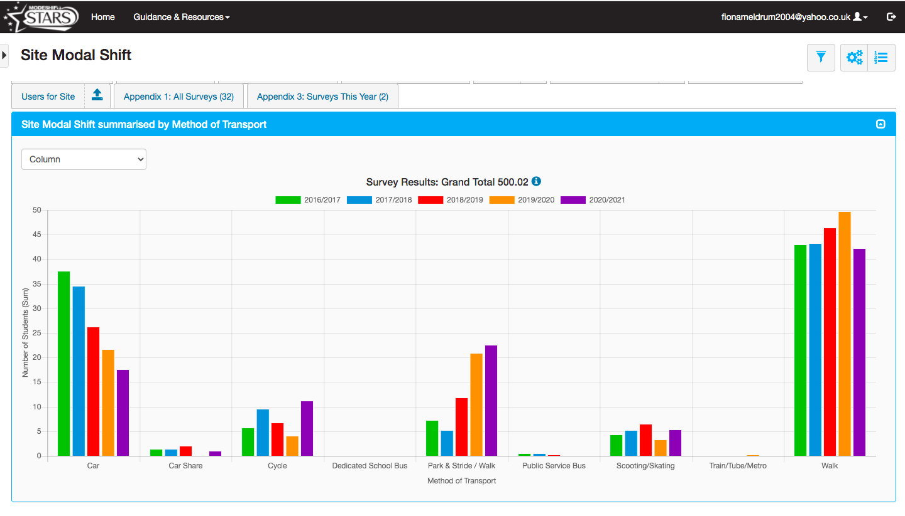  Kevin and I fully support the proposals to improve safety of the route to school. Bathampton Primary was B&NES’ first Gold Modeshift Stars school, and are fully committed to increasing active travel to school. It is vital that we support them in this venture by making access safer.

Appendix – Photos and description

Down Lane Crossing Issue

Summary
- The problem is that getting across Down Lane in the middle of Bathampton between Holcombe Lane and Devonshire Road has very poor visibility and not enough pavement on the Down Lane western side to make an easy or safe crossing from one half of the village to another.
- Although the speed limit is 20mph, this is almost never adhered to – Speedwatch wasn’t approved here by the Police due to a lack of escape route for those monitoring. This is partly because it is a steep road and vehicles are accelerating to get up it and also to get in and out of the two chicanes
- Parked cars along the length of the upper section make the issue much worse.
- Bathampton remains the rat run to the East of the city – both generally, as part of avoiding the CAZ and also currently with Cleveland Bridge shut. Traffic numbers are forecast to rise in council reports and modelling, in part due to the Enterprise Area
- There are approaching 800 houses in the village

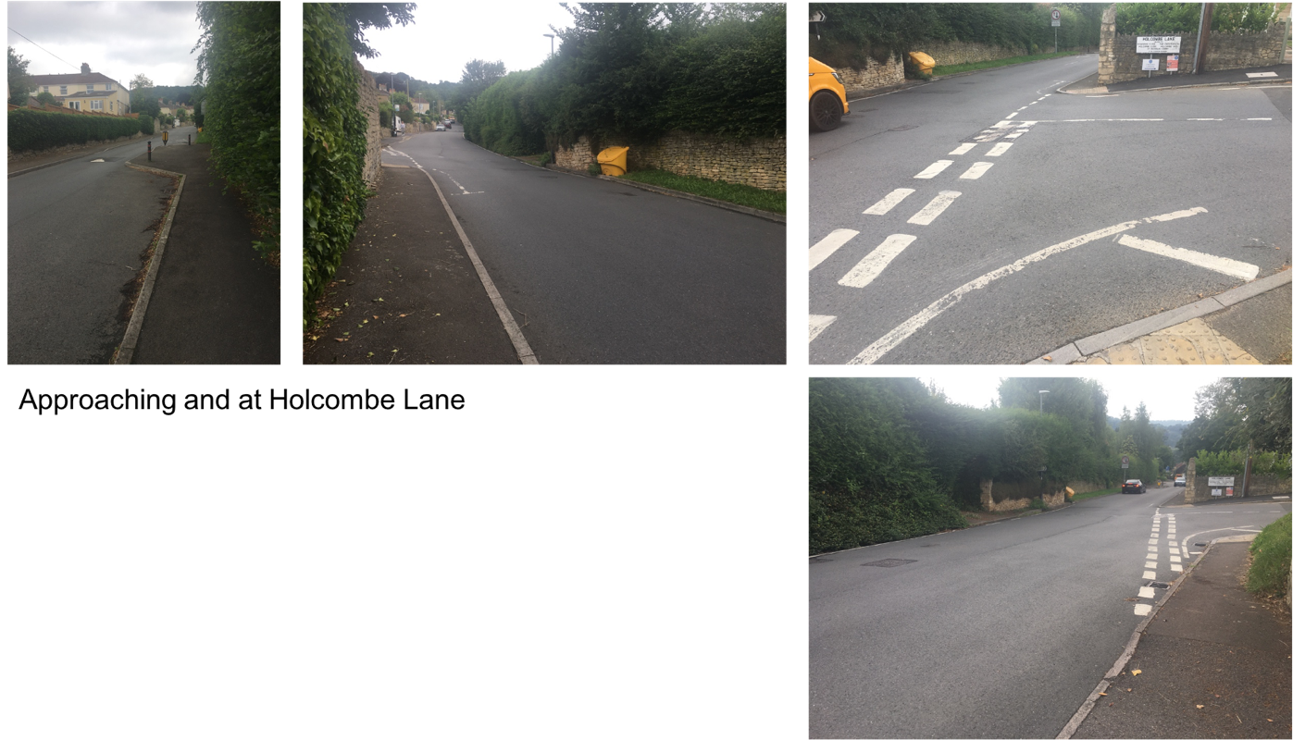

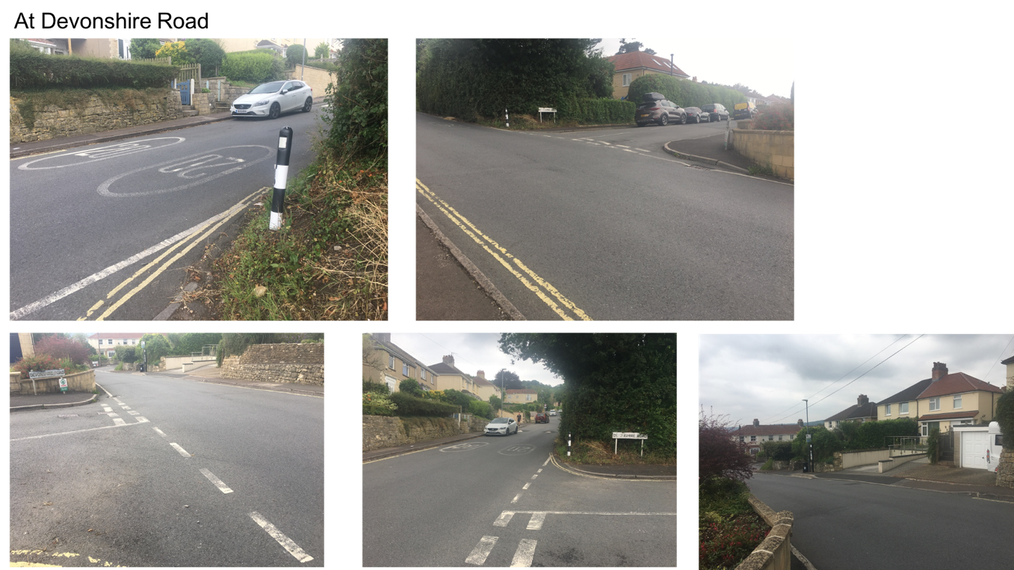

Canal Bridge and High St issues

Bathampton Parish Council , Safer Routes to School, Conker Crossing Alternative Paper

April 2022

Introduction
Bathampton has long been threatened by serious traffic congestion caused by traffic using the Toll Bridge and Village as a rat-run to travel between the A36 and the A4 as an alternative route to Cleveland Bridge for cross city traffic. This volume of traffic in a small village impacts:
- The safety of primary school children and their families going to/from school using the narrow, humped back, horseshoe bridge over the canal;
- The safety of all pedestrians throughout the village, especially:
  - The High Street, where vehicles frequently mount the pavement and houses open directly onto the carriageway.
  - Down Lane and its junctions with Devonshire Road and Holcombe Lane, where poor visibility and speeding vehicles are a danger to pedestrians crossing.
- The health, environment, and quality of life of residents caused by the resultant air and noise pollution.

In 2018, an association was set up to bring forward a community-endorsed foot and cycle bridge over the canal, Conker Crossing. The understanding with the then Head of Highways was that the community would bring the design forward as far of Planning and B&NES would take it on for detailed design, construction and adoption into the B&NES network. The project achieved planning permission; however, due to funding constraints and the forecast cost of the bridge the project has now stalled. More detailed summary of the Conker Crossing can be found here https://bathamptonconkercrossing.com/

The intention is that the requirements set out in this paper and consequential solution will form part of a Bathampton focussed Liveable Neighbourhood application for funding.

The Issues
Figure 1and Figure 2 shows the safety issues within the vicinity of the canal bridge and immediate areas. To note, 80% of children walking to school come along Dark Lane, with the remaining 20% through the High Street:
- The canal bridge (1) – a short humpback bridge, where 2 vehicles and pedestrians cannot cross safely at the same time. The marked crossing areas on either side of the canal bridge do not provide full visibility, especially for children and wheel chair uses, of vehicles travelling in either direction because of the nature of a humpbacked bridge;
- The narrowing between the High Street and Dark Lane (2) - Where 2 vehicles cannot pass at the same time without mounting the pavement;
- High Street (3) – a narrow street, with parked vehicles on one side and residential properties on the other that open directly onto the carriage way. Traffic speed up to ‘get through’ and mount the pavement when drivers do not pay due care and attention.
- The speed hump between The George Pub and the Church (4) - Does not have eye line signage, so vehicle overtake cars that have stopped to let pedestrians across the road.
- Down Lane (5) – Two junctions on Down Lane, Devonshire Road and Holcombe Lane, are exceptionally dangerous due to poor visibility, lack of pavements and excessive speeding. This is particularly challenging for children walking to school or passengers alighting from the D1 bus walking back into Bathampton village. This is part of the wider Safer Routes to School initiative.
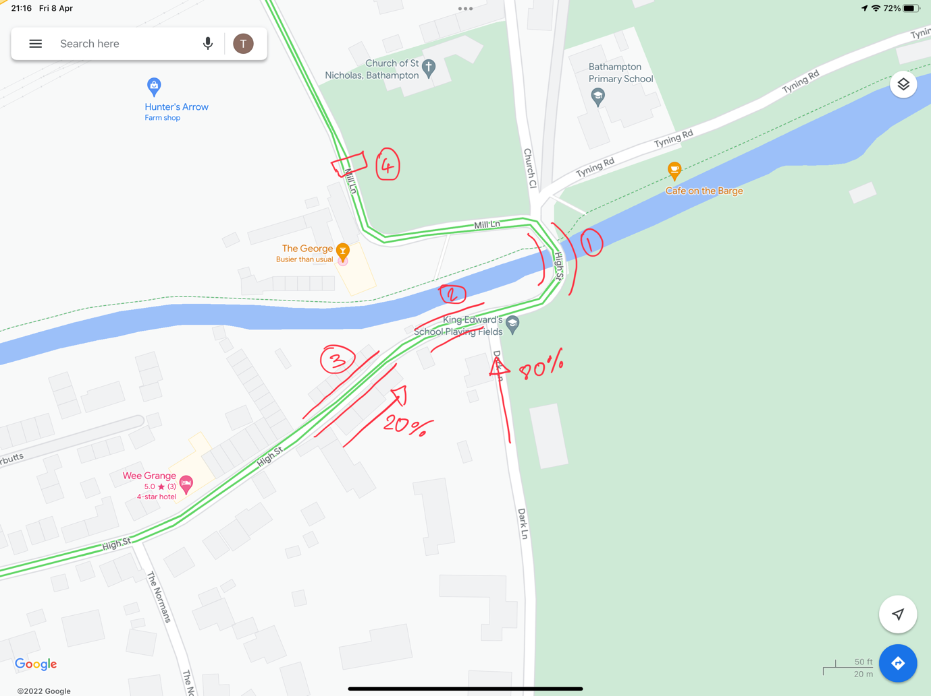
Figure 1 – Canal Bridge and High Street Issue

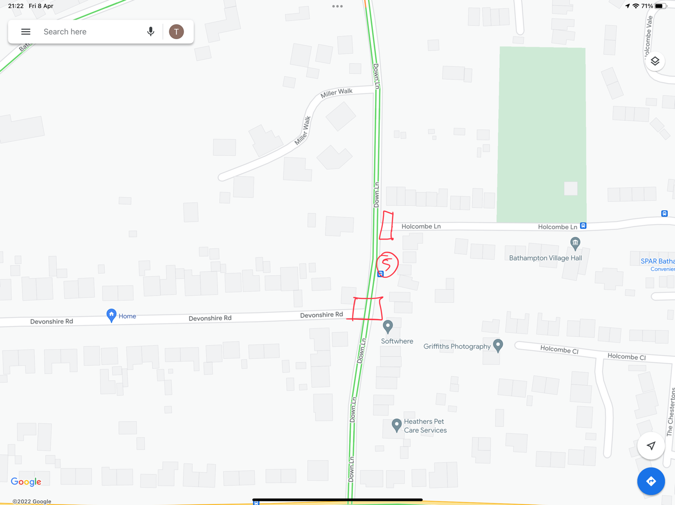
Figure 2 – Down Lane Issues

Requirements
The requirements set out here have been developed with residents (High Street, Parents of Bathampton School Children) and other stakeholders(Conker Crossing Trustees, Bathampton Safer Routes to School).
- Safer canal crossing for pedestrians
- Safer pavements for all pedestrians, especially on and between the High Street and Dark lane
- Slower average car speeds
- Improved motorist behaviour and driving
- Reduced traffic volumes improving Air Quality (AQ) and noise pollution
- Safer crossing between the George and the Church as a regular route to school
- Retention of on-street parking
- Better High Street environment
- Improved safety at the Down Lane junctions with Devonshire Road and Holcombe Lane.

Potential Solutions
The ultimate aims of any measures are:

The measures would:
- Remove unacceptable daily risks to children/vulnerable/elderly people crossing the canal bridge
- Challenge motorists to recognise these are village streets and to consider using principal roads
- Improve the environment
- Emphasise that roads are a shared space with pedestrians and cyclists
- Lower speeds and improve driver behaviour

There are a number of potential solutions to the issues the village residents are experiencing:

Canal Crossing
- Permanent Traffic Light – There are a number of different configuration, intelligence levels and schemes that could be applied to mitigate any issues. An additional paper has been developed exploring further traffic light configurations, which can be found in Annex A.
  - Pros
    - Safe
    - If the lights are placed at the end of the High Street this makes Mulberry Kidz narrowing one-way – this resolves mounting of the pavement. This would also make the bridge one-way, facilitating a full pavement being installed on the school side, further improving safety.
  - Cons
    - Knock on impact to rest of village, stationary traffic, increasing noise/AQ pollution.
    - Mitigation needed to prevent cars mounting pavement near high street (unless lights are on High Street
    - Solution could be complex and expensive
- Crossing Patrol
  - Pros:
    - Cheap & precise
  - Cons:
    - Only funded during school hours and term time
    - Difficult to recruit
    - Susceptible to out of operation due to ‘sick days’
    - Officially a non-standard crossing patrol as families walk the length of the bridge – not ideal from a safety perspective as a result
    - During school run, stationary traffic could cause cars to mount the pavement
- Bridge itself is a pelican-style crossing lengthways – assume location of lights is either side of the bridge
  - Pros:
    - Safe - On Demand Crossing
    - Alternative option of a single set of lights on the church side, making High Street traffic always have priority, see Annex B Signals options (Extract from PowerPoint) for potential options.
  - Cons:
    - Mitigation needed to prevent cars mounting the pavement on High Street. Barriers or full height pavements could be a solution.
Cars Mounting Pavement
- Full Height Pavements
  - Pro
    - Deters vehicles from mounting pavement, especially at speed.
  - Cons
    - Signage required to warn pedestrians of increased pavement height.
    - Will likely require one-way restrictions to undertake the work.
- Barriers to prevent cars mounting pavement
  - Pro
    - Cheap and effective
  - Cons
    - May not be feasible as pavement is already narrow
    - Need to consider safety of cyclists in narrow stretch who might be pinned against barriers
- Full height Pavements
  - Pros:
    - Improved Safety
  - Cons:
    - Expensive
Speeding, inconsiderate/dangerous Driving
- Traffic Calming
- Traffic enforcement
  - Permanent cameras not realistic
  - Mobile cameras
- Making the village look rural (Signs, planters, rustic gates)
  - Pros
    - Low Profile
  - Cons
    - Complex design to instil behavioural change
- Full width speed humps
  - Pros
    - Cheap and effective
  - Cons
    - Increased vibration for High Street residents
- Signage to encourage motorists to turn off their engines to reduce air pollution and noise.
Down Lane Visibility – part of Safer Routes to School
- Pedestrian crossing and additional pavements at the Devonshire Road and Holcombe lane junctions with Down Lane.
  - Pros
    - Proven safe
  - Cons
    - Can be expensive, however Wiltshire council have published (Link) rough costs of £21,500 to £34,000 per crossing.

A carefully designed and budgeted Liveable Neighbourhood Scheme which invests in redressing the balance between residents and motorists. One which incorporates street design and traffic measures which encourage more respect for pedestrians and village life and curbs/sanctions unacceptable behaviour

Canal Bridge Issue

Summary
- The problem is that the existing blind, humpback, horseshoe bridge is highly dangerous for all users – both those in a vehicle and not
- This existing road and pedestrian bridge is listed at Grade II.
We are aware of the sensitive location with respect to planning policy including the Conservation Area, Cotswold Area of Outstanding Natural Beauty and the Green Belt, as well as the heritage listing of the bridge.
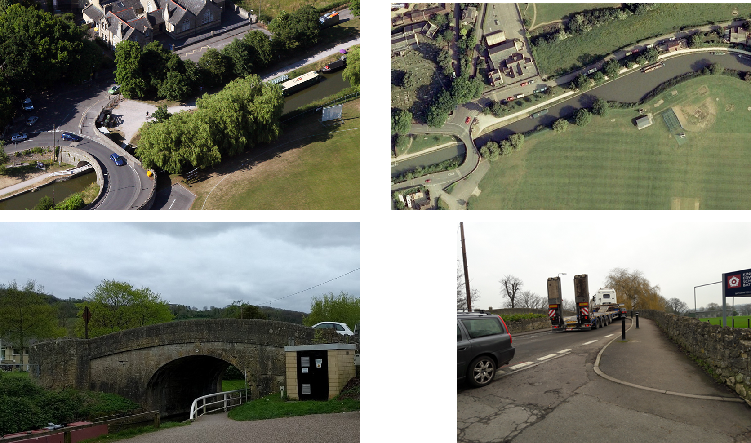

The existing blind, humpback, horseshoe bridge is highly dangerous.
- There are 4.5k vehicle movements across the bridge each day with peak flows coinciding with school pick up and drop off. Live satnav maps and other systems divert cars and LGVs along this route when the London Road is busy leading to an increase in the number of vehicles
- The canal bridge was not designed for cars, still less for cars and pedestrians to share. There is risk of injury or fatality because:
  - Vehicles cannot see bridge users from either direction due to its blind approaches and swing on to it without keeping close to their own side
  - There is insufficient space for two cars to pass without either:
    - encroaching on the pedestrian marked path, the side most Bathampton children cross on when coming from the village on their way to and from school (circa 100 children plus parents/carers and younger siblings)
    - mounting the pavement on the George pub side where pedestrians also stand to cross.
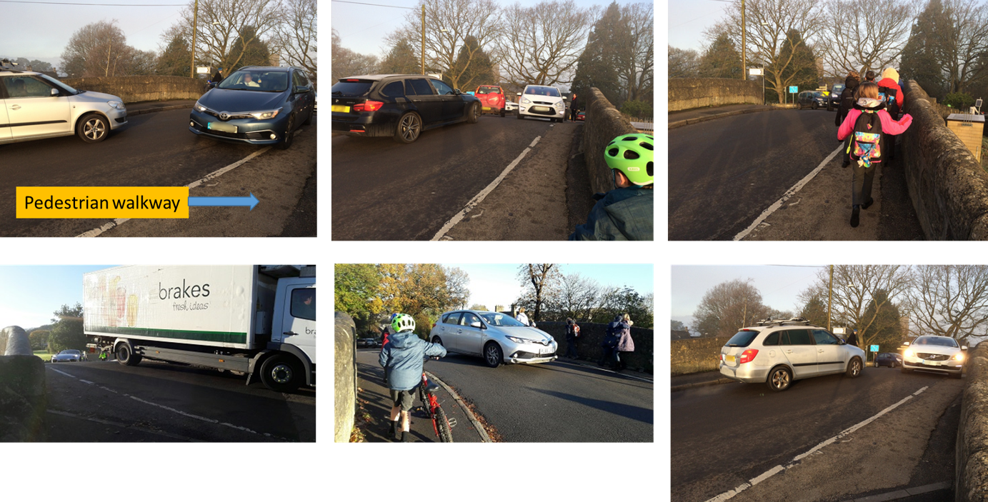

- These are the user groups:
  - Walkers and runners and leisure cyclists doing the canal/Bathampton circuit
  - Villagers accessing the pub and church
  - Bathampton Primary School children including independent walkers in years 5 and 6
  - The K&A canal path is part of the WECA strategic cycle route
  - The new development by Charlcombe Homes on Tyning Lane brings new users
  - There is a pedestrian route from Bathampton along Tyning Road to Bathford on a footpath
The critical time of day is school pick up and drop off weekdays – this is the largest single movement of people including children that are below the eye height of the cars swinging round the blind corners.

Source: https://www.enjoywalthamforest.co.uk/about-mini-holland/
Source: B&NES automated traffic count at Toll Bridge May 2014

